Edible Car

Nataly, Juan and Blessing
Engineering By Design
Mr. Cepeda
24 April 2015

Define a problem:
Build an edible car with your assigned group. The car must look and primarily function like a real car. The must first be sketched and agreed on my all team members of the group. The team when building the car must make sure it’s 3 inches maximum in height and depth and 6 inches maximum in length. The car must be built completely out of edible material.

Brainstorm Possible Solution
- A bread car with cookies for wheels and
- Car carved out of potato
- Car made out of carrots
- Gingerbread car
Generate 14 Possibilities Solution
- A car made from cucumbers with carrots for wheels and pretzels for an axle
- A bread car with cookies for wheels and
- Car carved out of potato
- Car made out of carrots
- Gingerbread car
- Cake car put in the freezer
- Cucumber car with candy wheels
- Car made with only bread. Bread wheels and axle
- Car made out of gummy bear
- Melt gummy candy put into a car cast
- Grounded cooked rice wrapped in seaweed
- Car carved out butter
- Car carved squash
- Car made from fondant painted with food coloring
Research Ideas and Explore Possibilities
We searched up Youtube videos for ideas on how to make a good axle that wouldn’t break or cause defects to our project. We searched up good body shapes to help the car go faster and not crash and break. Teaching Channel.org’s STEM edible car video showed all the ways that you can build an edible car and which one worked.
Specify Criteria and Identify Constraint
- The car must roll the down the ramp not slide
- The car must make it to the finish line in one piece
- Car must be made out of edible things
- Cannot use plastic or wood
- Must be 6 inches long
- Must be 3 inches long in depth and height
Consider Alternate Solution
- Use edible corn paste and mold the car shaper

Select Approach
Pick the 3 most favorable design and each person make the one they choose. The design must confirmed by all team members.
Develop Written Design Proposal
Make a Bread car with cookies for wheels. The car will be 2.5 inches in depth and 5 inches long. The car will have pretzel sticks as the axle. The stopper was Beef Jerky.
Make Model/Prototype

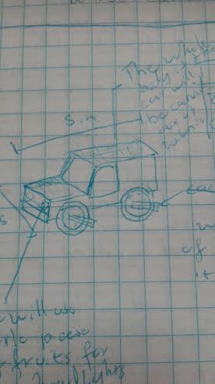

Test and Evaluate
First prototype was too big and went past the dimensions that given. When we tested the car it was rolling down and ramp and made it in one piece for the first time, but then it fell apart.

Refine/Create
We made the body of the car smaller and changes the dimensions to make it leaner.

Communicate Results

